* E-Project Second Semester (DISM)
* Aptech University Road Center
* Title : Music Factory (Music)
* No of Group members : 04
* Teacher : Sir Hamza Khan
* Duration : 6th Feb 2023 – 6th Mar 2023



**Music** factory

TEAM MEMBERS

* Jahangir Riaz Siddiqui
* Syed Usman Hasany
* Isra
* Kaif

Has Successfully Designed a website on *Music* as a project of 2nd Semester (DISM), Aptech University Road Center, Gulistan-e-Johar Center, Karachi.

* Aptech University Road Center

ACKNOWLEDGEMENT

The Following Project is completed by *Jahangir Riaz Siddiqui, Syed Usman Hasany, Isra, Kaif* of DISM (2nd Semester) *Aptech University Road Center, Karachi* We managed to create an easy interface and controls for our users along with a beautiful GUI having pages(*home, Songs,Video-Songs*)

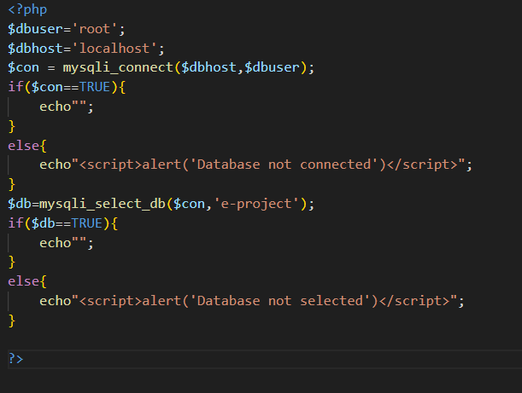

Database Connectivity

Source code Database

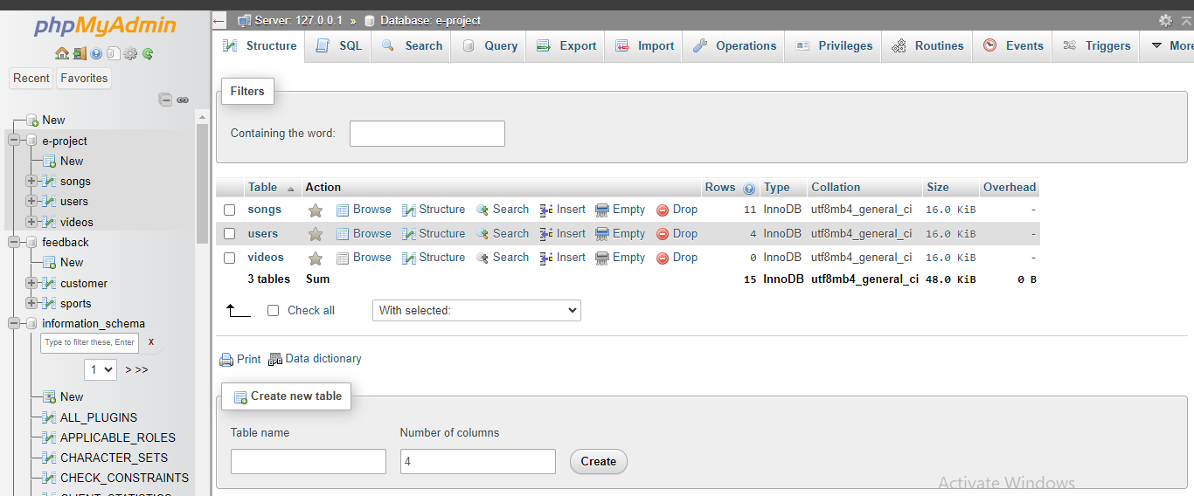

MySQL Database Tables

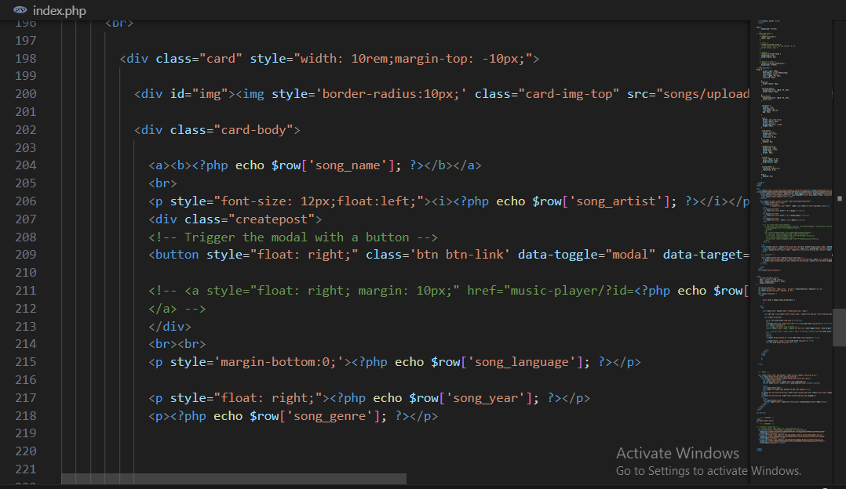

Index Page

Source code Index Page

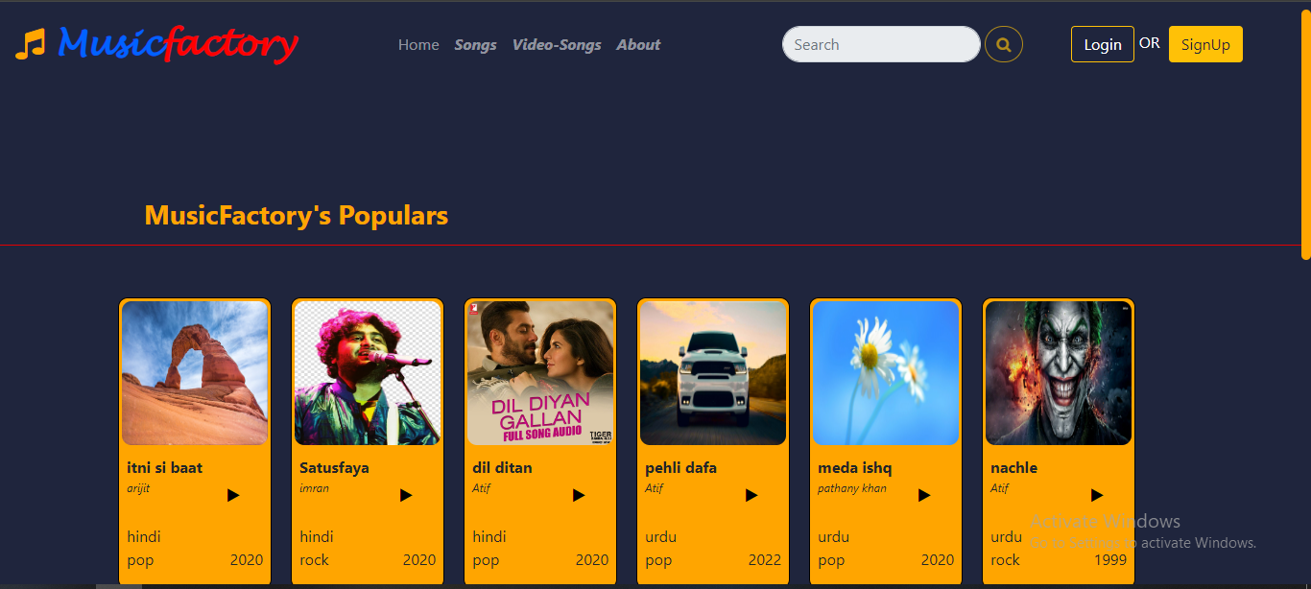

Final output Index Page

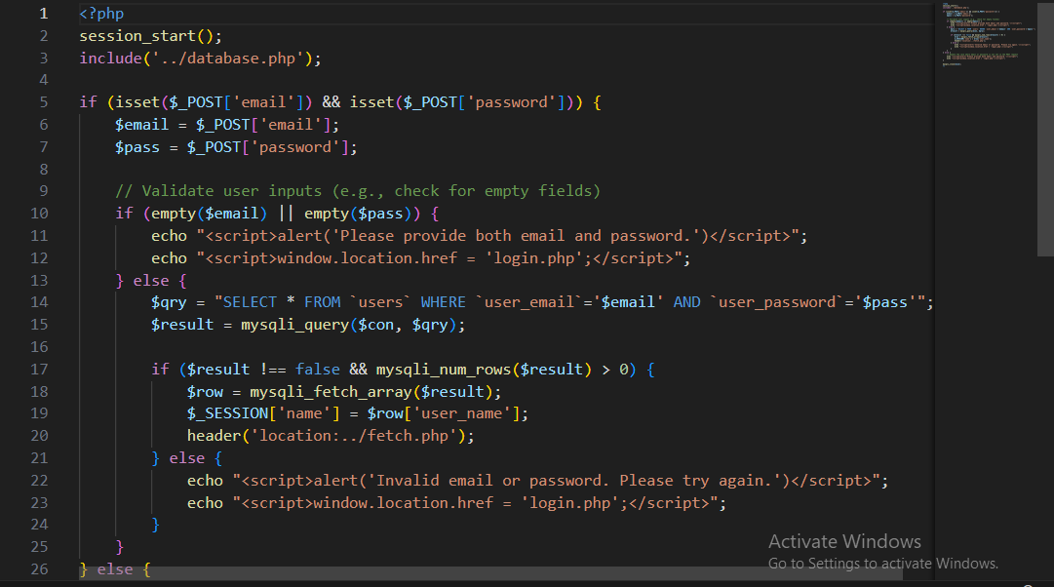

Signup Page

Source code Sign-up

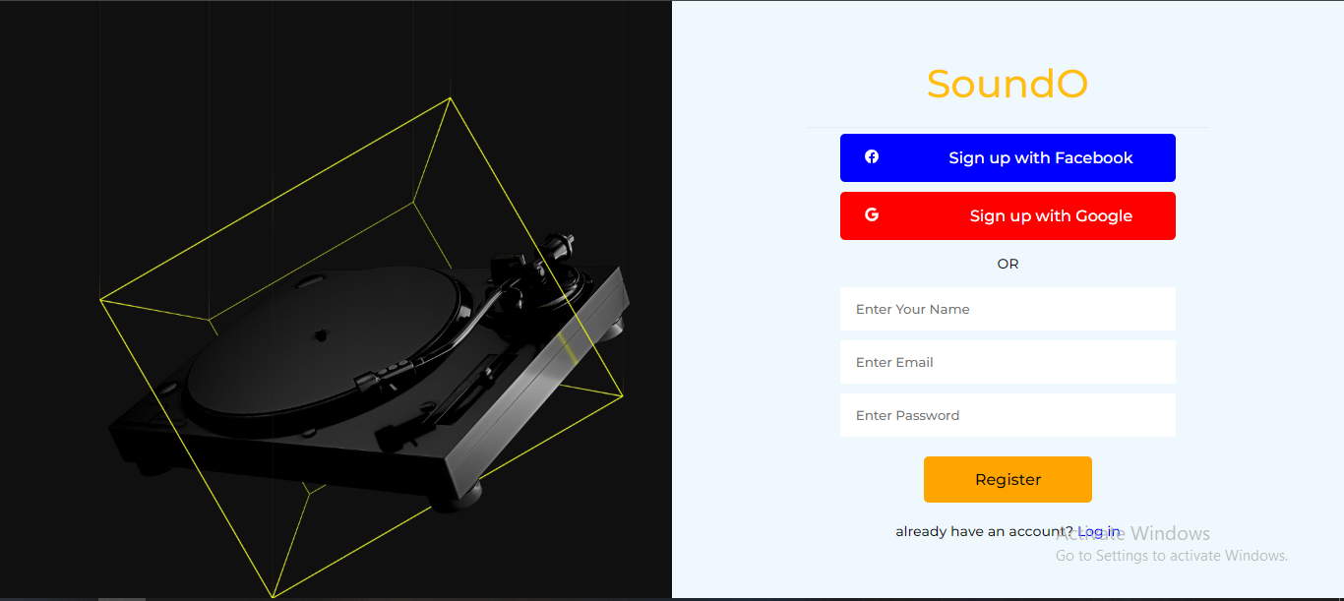

Final output Sign-up

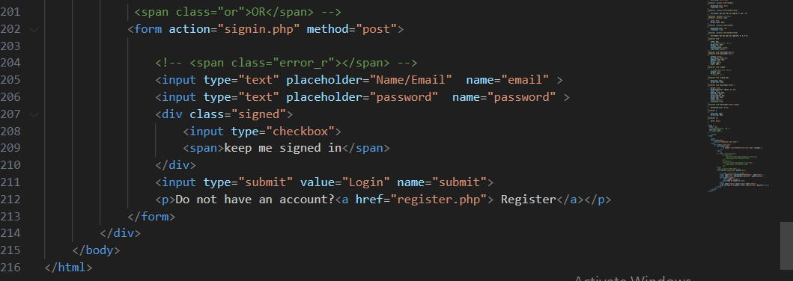

Login Page

Source code Log-in Page

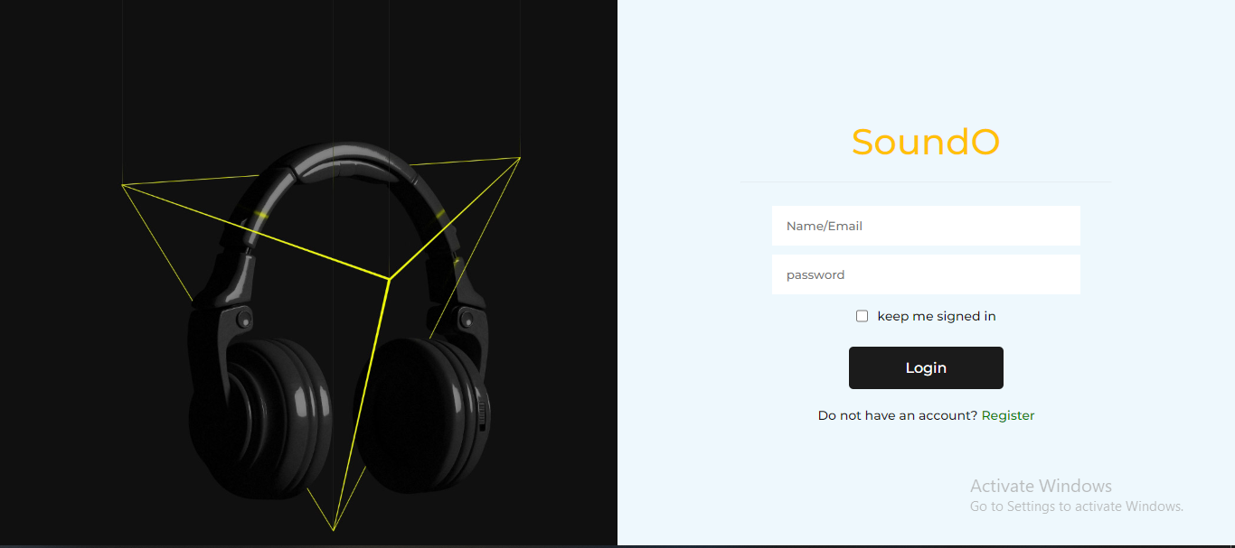

Final output Log-in Page

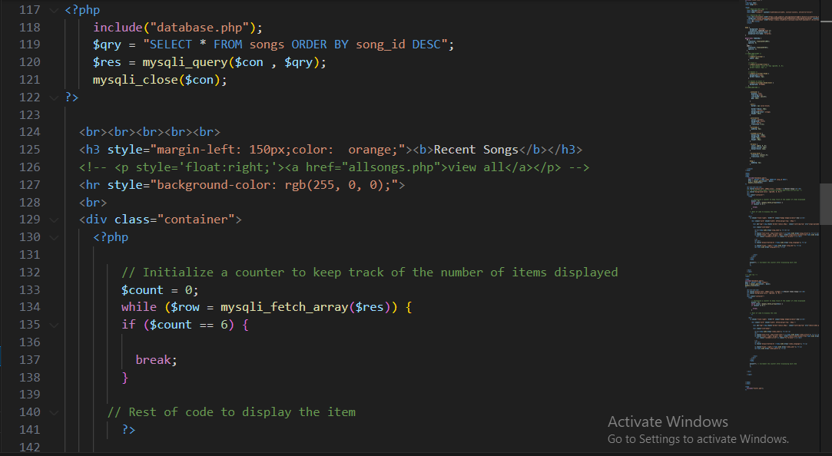

Home Page

Source code Home Page

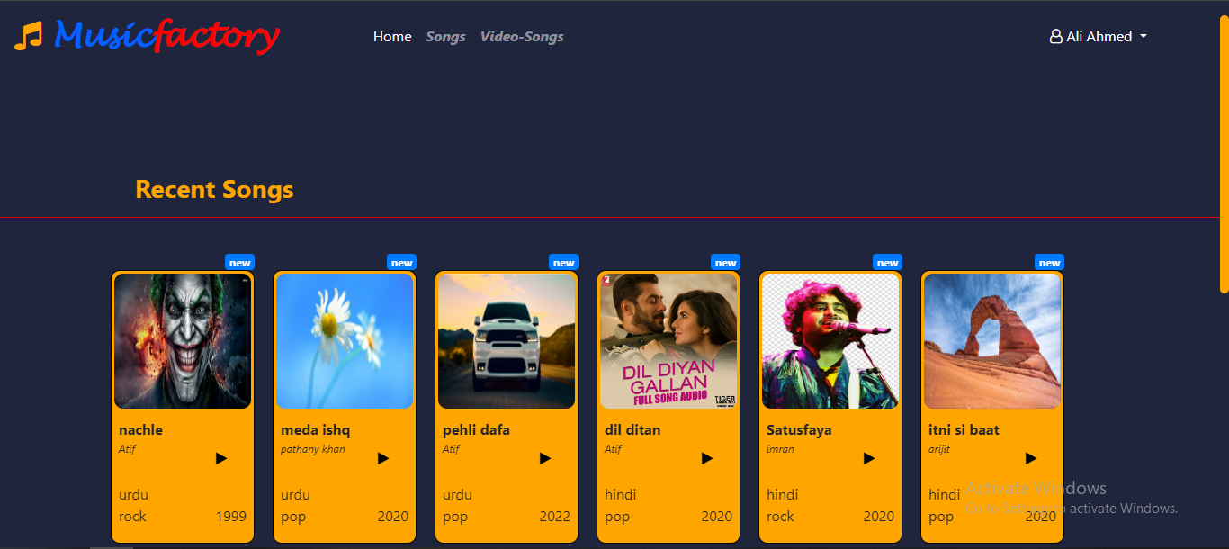

Final output Patient Education Page

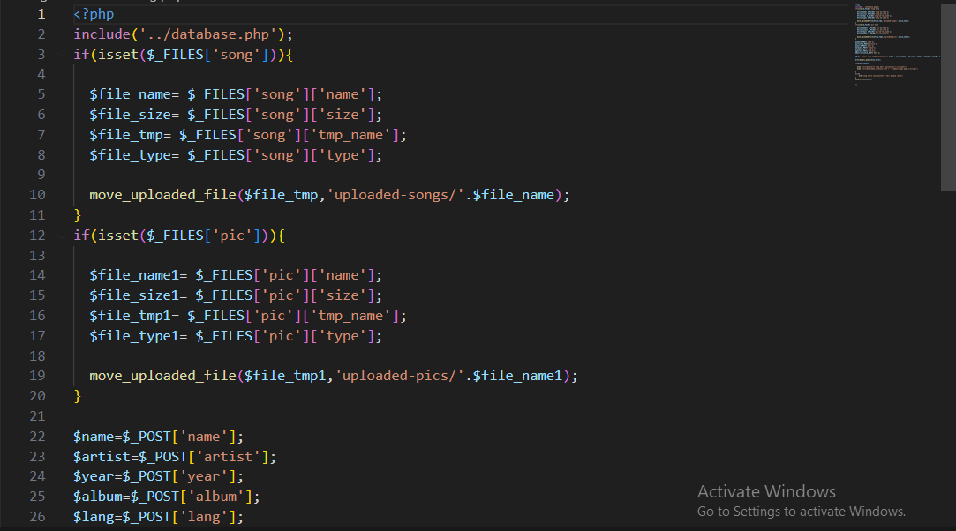

Songs

Source code Songs Page

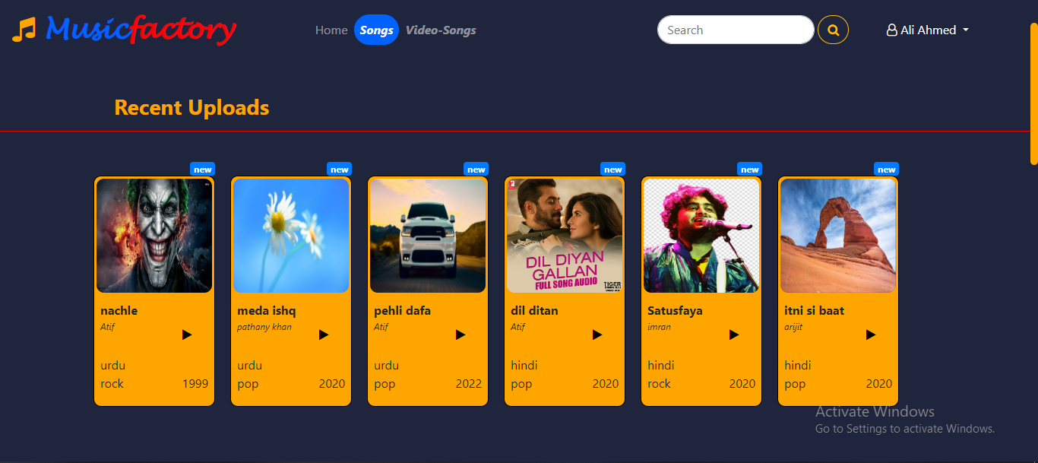

Final output Songs Page

Video Player Code

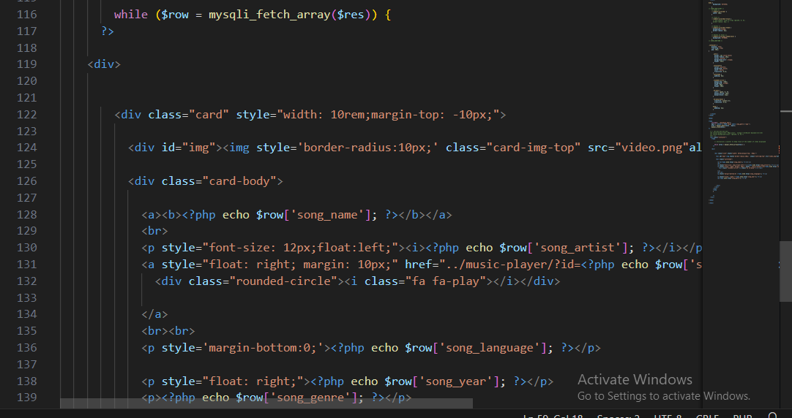Songs

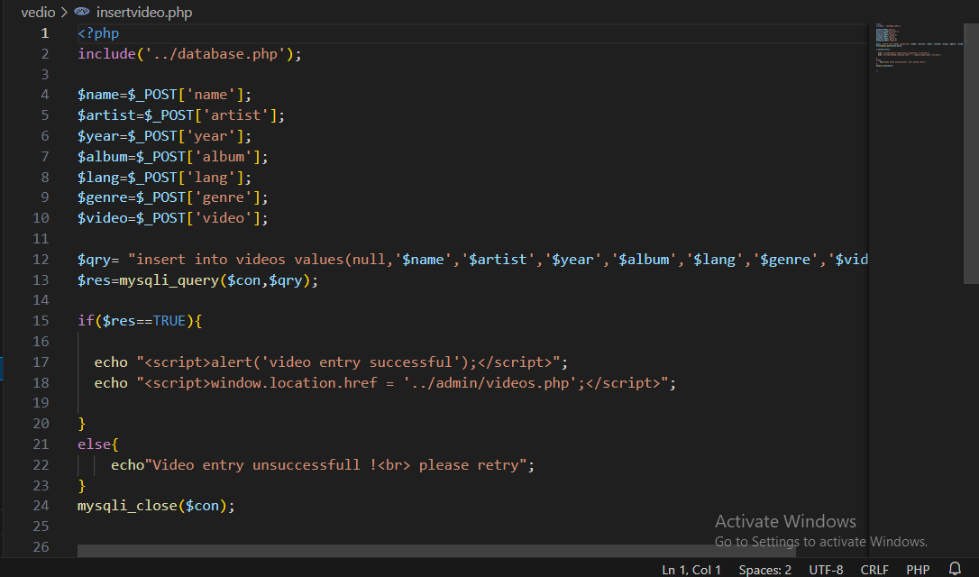

Video-Songs Page

Source code Video Songs Page

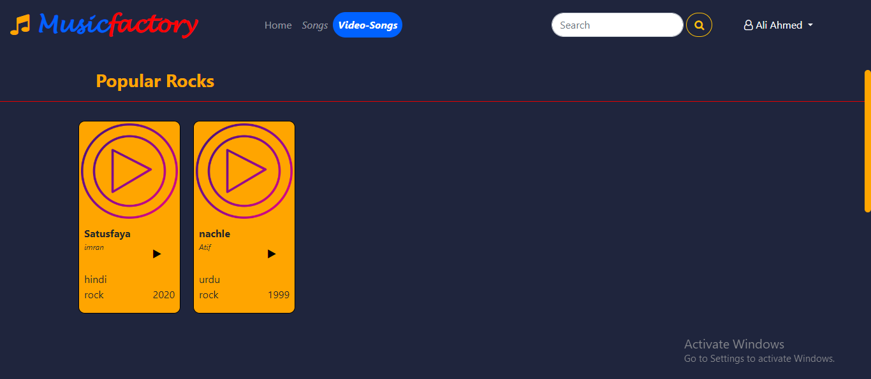

Final output Video Songs Page

Songs



Video Player Code

Source code Video Player Page

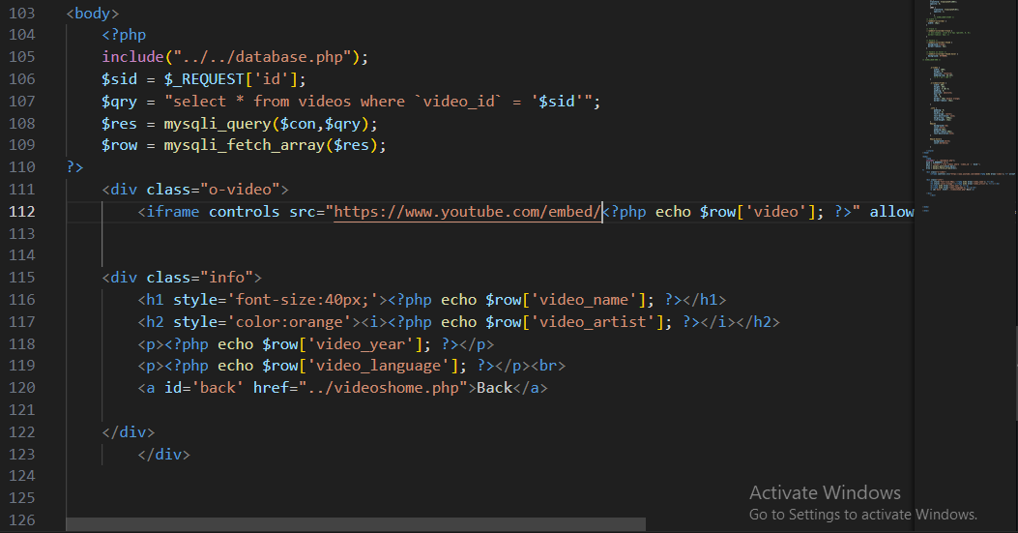

Final output Video Player Page

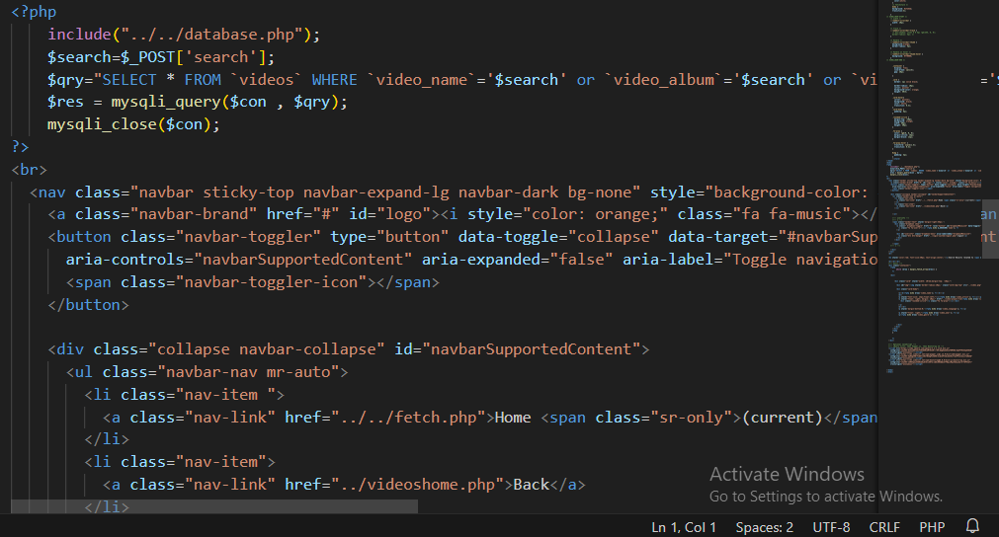

Searchbar

Source code Searchbar

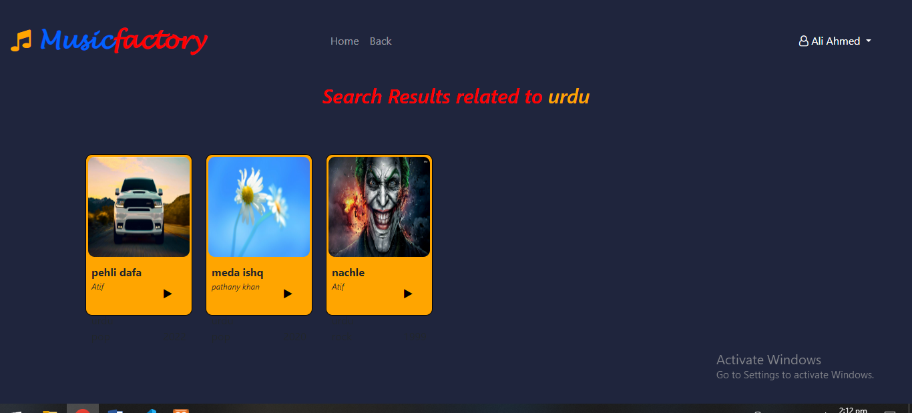

Final output searchbar

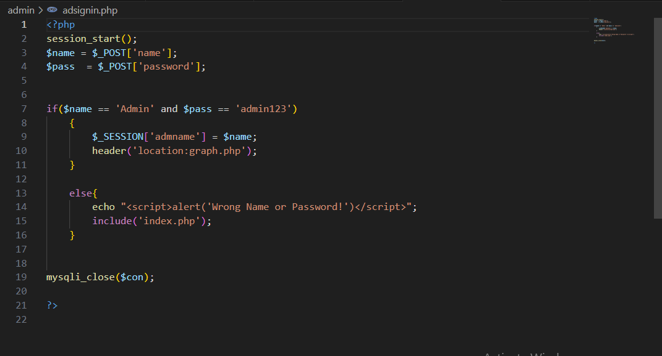

Admin login

Source code Admin login Page

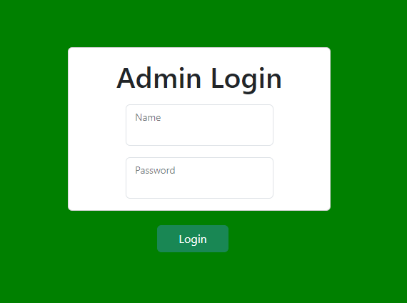

Final output Admin Login Page

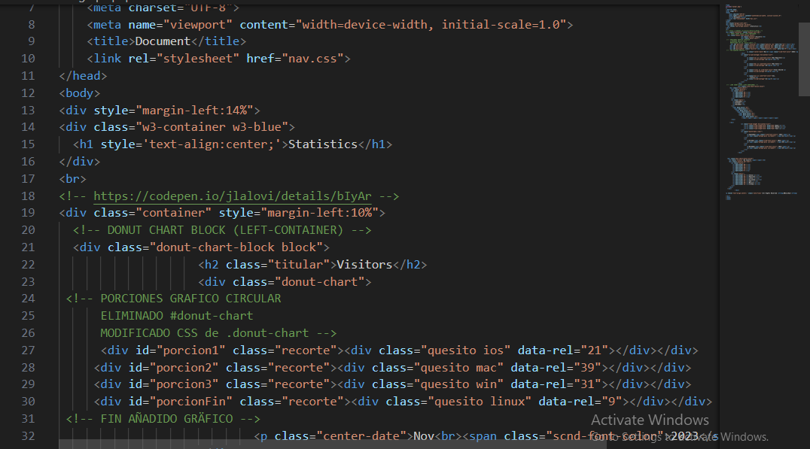

Admin Dashboard

Source code Admin Dahsboard Page

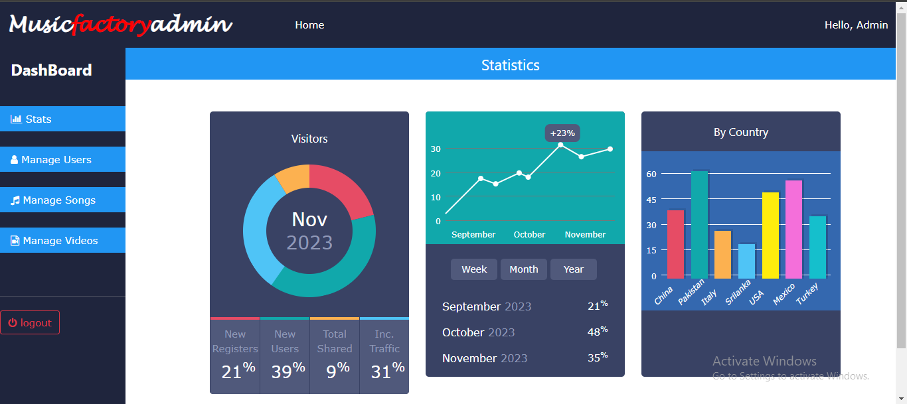

Final output Admin Dahsboard Page

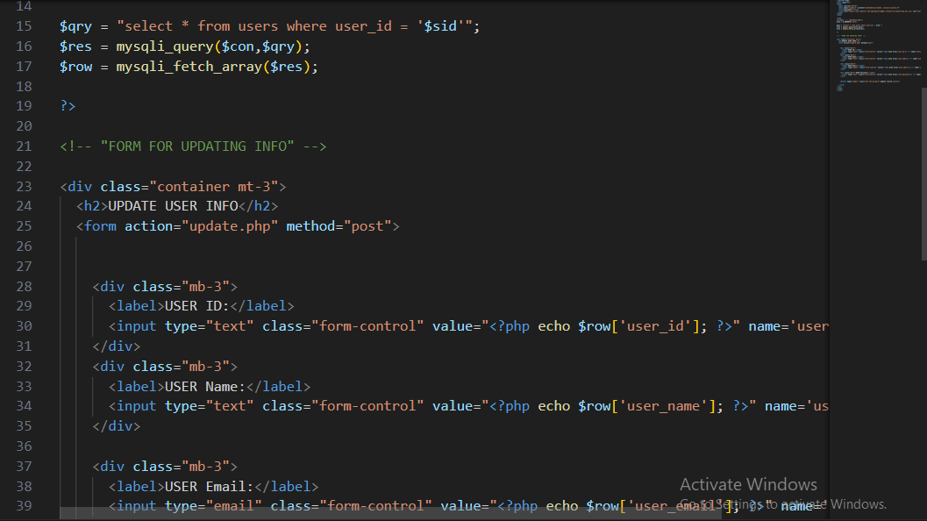

Admin Manage Users

Source code Admin Manage Users Page

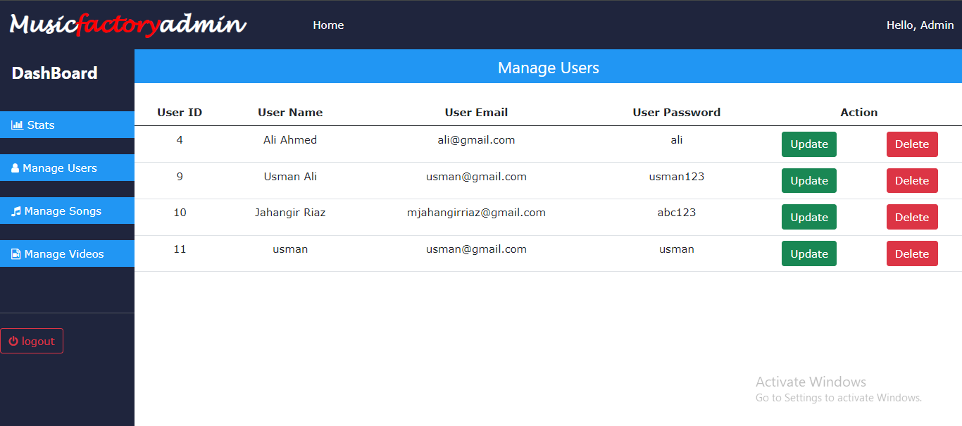

Final output Admin Manage Users Page

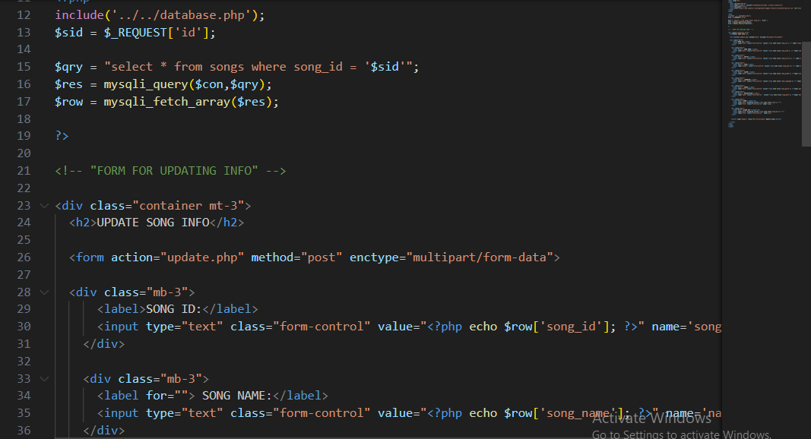

Admin Manage Songs

Source code Admin Manage Songs Page

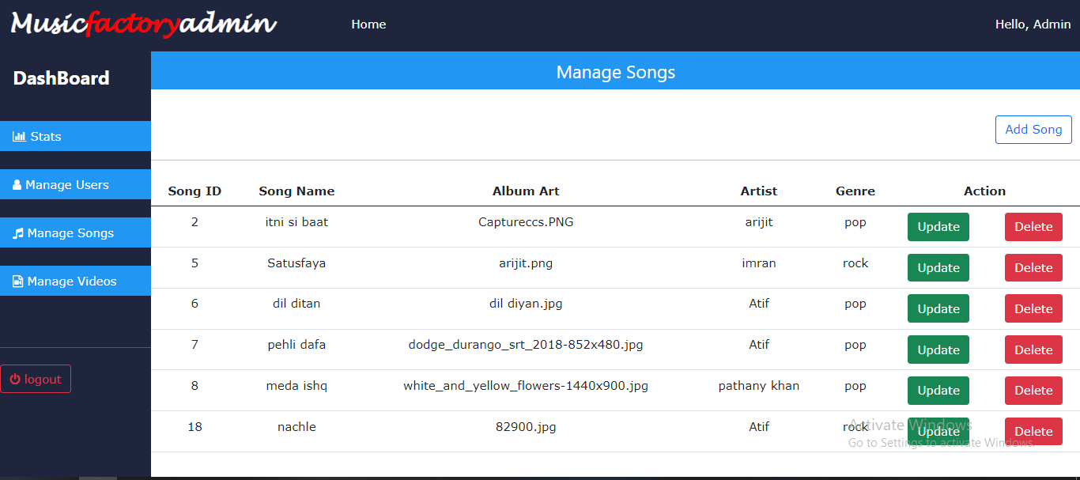

Final output Admin Manage Songs Page

**Introduction**

The thirst for learning, upgrading technical skills and applying the concepts in real life environment at a fast pace is what the industry demands from IT professionals today. However busy work schedules, far-flung locations, unavailability of convenient time-slots pose as major barriers when it comes to applying the concepts into realism. And hence the need to look out for alternative means of implementation in the form of laddered approach.

The above truly pose as constraints especially for our students too! With their busy schedules, it is indeed difficult for our students to keep up with the genuine and constant need for integrated application which can be seen live especially so in the field of IT education where technology can change on the spur of a moment. *Well, technology does come to our rescue at such times!!*

Keeping the above in mind and in tune with our constant endeavour to use Technology in our training model, we at Aptech have thought of revolutionizing the way our students learn and implement the concepts using tools themselves by providing a *live and synchronous eProject learning environment!*

**So what is this eProject?**

eProject is a step by step learning environment that closely simulates the classroom and Lab based learning environment into actual implementation. It is a project implementation at your fingertips!! An electronic, live juncture on the machine that allows you to

* Practice step by step i.e. laddered approach.
* Build a larger more robust application.
* Usage of certain utilities in applications designed by user.
* Single program to unified code leading to a complete application.
* Learn implementation of concepts in a phased manner.
* Enhance skills and add value.
* Work on real life projects.
* Give a real life scenario and help to create applications more complicated and useful.
* Mentoring through email support.

The students at the centre are expected to complete this eProject and send complete documentation with source code to eProjects Team

Looking forward to a positive response from your end!!

**Objectives of the project**

The Objective of this program is to give a sample project to work on real life projects. These applications help you build a larger more robust application.

The objective is not to teach you concepts but to provide you with a real life scenario and help you create applications using the tools.

You can revise them before you start with the project.

It is very essential that a student has a clear understanding of the subject.

Kindly get back to eProjects Team in case of any doubts regarding the application or its objectives.

**Problem Statement**

Music and Video’s are the most common source of entertainment today.

SOUND Group wants to host a WEBSITE for Entertainment. Company is looking on hosting new and old Video’s and Songs in both REGIONAL and ENGLISH language.

WEBSITE should have proper menu structure and Music and Video should be arranged as per ALBUM, ARTIST, YEAR, GENRE, LANGUAGE etc.

Users should have option of reviewing and rating the Music and Video’s available.

Home Page should have information about the site and a section for latest music and video with 5-5 listing in each.

**Customer Specifications:**

Website will host information about songs and videos with images and description and “New” image/icon should flash along with the new additions to Music and Video’s.

The website will have three users/roles:

1. Administrator
2. USER

The Administrator should be able to do the following:

1. Add Music files with information.
2. Add Video files with information.
3. Create Categories viz. YEAR, ARTIST, ALBUM etc.
4. Delete Music files
5. Delete Video files.
6. Create/Manage Users/Logins
7. Manage information/details on the WEBSITE

The USER should be able to do the following:

1. Register/Create Account [USERID should be unique].
2. Search for MUSIC/Video based on Name, ARTIST, YEAR, ALBUM etc.
3. ADD/Modify Reviews
4. ADD/Modify Ratings

Note: Name, Address, Phone Numbers, Email-ids should be mandatory to be provided. Proper Validations should be applied on all Data Fields.

Project should be submitted along with proper documentation and Database Backup.